
Basic Guide

Chapter ?
Syntax Diagrams
For Basic, VBA

Kopyright
This document is Copyright © 2020 by the LibreOffice Documentation Team. Contributors are listed below. You may distribute it and/or modify it under the terms of either the GNU General Public License (http://www.gnu.org/licenses/gpl.html), version 3 or later, or the Creative Commons Attribution License (http://creativecommons.org/licenses/by/4.0/), version 4.0 or later.
All trademarks within this guide belong to their legitimate owners.

Contributors
This book is adapted and updated from Basic Guide OpenOffice.org 3.3.

To this edition
Alain Romedenne

To previous editions

Feedback
Please direct any comments or suggestions about this document to the Documentation Team’s mailing list: documentation@global.libreoffice.org
- Note:
Everything you send to a mailing list, including your email address and any other personal information that is written in the message, is publicly archived and cannot be deleted.

Publication date and software version
Published October 2024. Based on LibreOffice 6.2.
Contents
Kopyright 2
Contributors 2
To this edition 2
To previous editions 2
Feedback 2
Publication date and software version 2
Introduction 5
Using LibreOffice on a macOS 5
Other useful information about this guide chapter 5
Page styles 5
Cover (First Page) styles 5
Heading 1 6
Heading 2 6
Heading 3 6
Figures 6
Adding figures 6
Figure formatting 7
Tables 8
Notes, Tips, and Cautions 9
Lists 9
Numbered lists 9
Bullet lists 10
Simple lists 10
Definition lists 10
Other paragraph styles 10
Character styles 11
Cross referencing 12
Data Types, Constants & Variables 16
16
Basic compiler options 16
Option statement 16
Data type conversion 16
Constants & variables 16
Scope of declarations 16
Accessers 17
Constants 17
Variables 17
Dim statement 17
Let/Set statement 17
Redim statement 18
Type … End Type statement 18
Arrays 19
Collections 19
Variants 19
Booleans values 19
Date /Time 19
Expressions & Operators 19
Procedures: Subs, Functions & Properties 19
Calling routines 19
Call statement 19
Declaring routines 19
Sub statement 19
Function statement 20
Property Get/Let statements 20
Interrupting flow: Exit … 21
GoSub … Return statement – Internal routines 21
Arguments 21
Return values 21
File Handling 21
Error Processing 21
With LibreOffice Basic 21
Erl function 21
Err function 21
Error function 21
Error statement 22
On … Error … 22
Resume statement 22
CvErr function 22
IsError function 22
With VBA 22
Conclusions 23
Exception Class - e.Number=Err, e.Description=Error$, e.Source 23
try: … catch: … finally: … 23
User-Defined Data Types & Classes 23
Managing Flow of Control 23
Testing conditions 23
Iterating 23
Branching 23
Internal routines 23
Exit … - Interrupting Flow of Control 23
Events Driven programming 23
Beyond LibreOffice Basic 23
Python Scripting 23
JavaScript Programming 23

Introduction
- IMPORTANT — Keep in mind this is a Style template
While the text of this document contains some useful pointers about styling chapters for our documentation, it is first and foremost a STYLES template, NOT an alternative or a substitute for the Contributors Guide.
When creating or updating guide chapters always apply the styles provided by this template. NEVER apply manual formatting by using the icons on the formatting toolbar, or by using keyboard shortcuts (eg. Ctrl+B for bold text)
This small section outlines what will be covered in the chapter, plus any other additional information to assist the reader in understanding the content.

Using LibreOffice on a macOS
Some keystrokes and menu items are different on macOS from those used in Windows and Linux. The table below gives some common substitutions for the instructions in this book. For a more detailed list, see the application Help.
Windows or Linux | macOS equivalent | Effect
Tools > Options menu | LibreOffice > Preferences | Access setup options
Right-click | Control+click or right-click depending on computer setup | Open a context menu
Ctrl (Control) | ⌘ (Command) | Used with other keys
F5 | Shift+⌘+F5 | Open the Navigator
F11 | ⌘+T | Open the sidebar Styles deck

Other useful information about this guide chapter
Information you think might be helpful to anyone reading the chapter in isolation from the full book.

Page styles
This template uses 3 page styles:
First Page
Used for the chapter’s title page. The following page style is Font Matter.
Front Matter
Used for the copyright and contents pages. The following page style is Default Style.
Default Style
Used for all other pages.

Cover (First Page) styles
Guide Name
Use for the name of the user guide on the cover page.
Title
Use for the title of a chapter in a user guide. The following paragraph style is Subtitle.
Subtitle
Use for the optional subtitle of a chapter. This paragraph style has a page break after the paragraph to force the Copyright section to start on a new page. If the chapter does not require a subtitle, delete any text, but DO NOT delete the paragraph because it is used as a page break to start the Front Matter page style.
Contents Heading
Used automatically by LibreOffice for the word “Contents” on the Table of Contents page. This style prevents the heading from appearing in the table of contents.

Heading 1
The heading above is an example of what a Heading 1 will look like.
A Heading 1 is Included in the Table of Contents.

Heading 2
The heading above is an example of what a Heading 2 will look like.
A Heading 2 is Included in the Table of Contents.

Heading 3
The heading above is an example of what a Heading 3 will look like.
A Heading 3 is Included in the Table of Contents.

Figures

Adding figures
To have consistent styling and anchoring for all graphics (images and illustrations) shown in our documentation the following steps are the recommended procedure.
- Create a blank paragraph where the graphic is to be added and set the paragraph style to Figure.
- Insert or paste the graphic.
By default it will be selected and anchored to the paragraph.
- Right-click on the image and select Insert Caption from the context menu.
- Enter the caption details and click OK.
By default the graphic will be enclosed within a frame and the caption will have the Figure paragraph style.
- Right-click the frame and select Anchor as Character from the context menu.
- Click outside the frame to deselect it.
- Right-click on the image and select Anchor to Paragraph from the context menu.
- Click anywhere within the caption text, then apply the Caption paragraph style.
Figure 1: Example of correctly added figure

Figure formatting
The previous heading outlines the steps to add a caption, but there will be times when it becomes necessary to reformat or re-anchor the figure or one of it’s components.
Graphics, and their captions use the following styles. Figure 1 is an example of a correctly added figure.
Figure
Used for paragraphs that places a frame for a graphic in the horizontal center of a paragraph. This type of paragraph does not contain any text and is used to position the graphic frame and the figure caption. It is to be used for all graphics. The following paragraph style is Text Body.
Caption
Used for all captions and is positioned below a figure, which is the default setting, using Insert > Caption. Figure captions are automatically numbered using the category Figure.
Frame
This frame style is the default style for the frame when a Caption is added to a graphic. It is aligned centrally for horizontal and vertical placement when inserted next to the Figure paragraph style. A graphic is automatically placed into a frame with no spacing.
Anchor the frame to the Figure paragraph style using the option Anchor as Character.

Tables
Tables are used to explain data in a tabular format. A sample table is shown in Table 1. This sample table can be copied and pasted into a document so that the table properties will remain the same for tables used in a document. All you have to do is to add or delete columns and rows or replace the cell contents.
Table 1: Sample table. The Caption style is used for this paragraph.
Windows or Linux | macOS equivalent | Effect
Tools > Options menu selection | LibreOffice > Preferences | Access setup options
Right-click | Control +click and/or right-click depending on computer setup | Open a context menu
Ctrl (Control) | ⌘ (Command) | Used with other keys
F5 | Shift+⌘+F5 | Open the Navigator
F11 | ⌘+T | Open the Styles and Formatting window
Table Contents
This paragraph style uses a slightly smaller font size than the Text Body style used. It allows more data to be entered into a table cell. As can be seen in the sample table, you can use character styles with Table Contents.
Table Heading
This paragraph style is used in the header row of a table and is the same font size as Table Contents, but uses Bold Italic for emphasis.
Caption
This is the same as the caption used for figures, but is positioned above the table. This has to be set manually when inserting a caption using Insert > Caption on the Menu bar. Table captions are automatically numbered using the category Table.
Header rows
A table can have as many columns and rows as necessary, but the first row of a table is always the header row. This header row is set to repeat on following pages if the table is split across more than one page.
Table rows
For clarity when using tables, table rows do not break across pages and columns. If a table cell in a row contains too much data that forces a row onto the next page leaving a large blank space if there was no break in the row, then rethink the data. This helps to improve the clarity of a table.

Notes, Tips, and Cautions
Important: For the Note, Tip and Caution Headings to function as intended, new headings of this type must be created by first creating 3 empty paragraphs (ie. 3 carriage returns). Then the appropriate heading style is applied to the first/upper paragraph. When the heading is completed press the Enter key and the next paragraph style will change to Text Note.
- Note
A note is used when something has to be drawn to the attention of the user and possibly prevent any user errors.
A note begins with the paragraph style Heading Note. The text of a note uses the paragraph style Text Note and automatically follows Heading Note.
- Tip
A tip is a suggestion that could make it easier for a user to do something easier and better in LibreOffice.
A tip begins with the paragraph style Heading Tip. The text of a tip uses the paragraph style Text Note and automatically follows Heading Tip.
- Caution
A caution is only used when there could be serious damage to the file or software if the user does not follow the correct procedure. Some cautions in the user guides could really be reclassified as notes.
A caution begins with the paragraph style Heading Caution. The text of a caution uses the paragraph style Text Note and automatically follows Heading Caution.
The line (border) below the Text Note paragraph is automatically drawn when the above headings are completed and the Enter key is pressed.
When the Text Note is completed do not use the Enter key for the next paragraph, simply press the down arrow key to reach the third/lower empty paragraph and apply the require style for that paragraph.
In the process of adding these headings and notes a fourth empty paragraph will have been automatically added and should be manually deleted.

Lists

Numbered lists
At the start of each level of every numbered list in your document, you have to right-click on the first step in that level and select Restart Numbering from the context menu. Be sure to do this for the first list as well as later lists, to ensure correct numbering when chapters are combined into a book.
Numbered lists use the paragraph style Numbering 1. This paragraph style uses the list style also named Numbering 1. The list style allows for several levels of nesting in a numbered list.
An example of a numbered list with three levels of numbering is as follows:
- Numbering 1
- Numbering 1. Example of a long item that wraps around to the next line. Example of a long item that wraps around to the next line.
- Numbering 2.
- Numbering 2. Example of a long item that wraps around to the next line. Example of a long item that wraps around to the next line.
- Numbering 3. Only used when really necessary.
- Numbering 3. Example of a long item that wraps around to the next line. Example of a long item that wraps around to the next line.
- Numbering 2
- Numbering 1

Bullet lists
An example of a bullet list is as follows:
- List 1
- List 1. Example of a long item that wraps around to the next line. Example of a long item that wraps around to the next line.
- List 2
- List 2. Example of a long item that wraps around to the next line. Example of a long item that wraps around to the next line.
- List 1

Simple lists
Simple lists use the Text Body Indent paragraph style and do not have bullet points or numbers. Use simple lists only when all of list items are no longer than one line of text. At the end of each item in a simple list use Shift+Enter to insert a line break and move to a new line. After entering the last item in a simple list, use Enter to create a new paragraph and change the paragraph style.
An example of a simple list is as follows:
Text Body Indent
Text Body Indent
Default Text Body.

Definition lists
Definition lists are used mainly for short explanations of terms that may not be familiar to a user, for example fields or options in dialogs. Each item in a definition list consists of two parts: the definition term, which uses Definition Term as the paragraph style, and the definition itself, which uses Text Body Indent for the explanation of the definition term.
An example of a definition list is as follows:
Definition Term
Text Body Indent used to explain the definition.
Definition Term
Text Body Indent used to explain the definition.

Other paragraph styles
Text Body
The default for any paragraph not otherwise styled.
Text Body Indent
The same as Text Body, with a 1cm indentation
Code
Used when an entire paragraph is computer code, for example a command line or lines of computer code. This paragraph style uses a monospace font – Liberation Mono. See also the code character style which is used when only part of a paragraph needs to have this style applied.
This is an example of Code paragraph style.
This is an example of Code End paragraph style.

Character styles
For additional formatting within a paragraph, use an appropriate character style. Do NOT use the italics or bold formatting buttons on the Formatting Toolbar, Sidebar Properties Panel or keyboard shortcuts.
Emphasis
This italics character style is built in to LibreOffice. Use it for the following:
Chapters referred to, for example Chapter 1 Introducing Impress
Books and user guides referred to, for example Impress Guide
Options in LibreOffice dialogs, for example As character, Format.
Other terms that are commonly italicized in English usage.
Strong Emphasis
This bold character style is built in to LibreOffice. Use it for terms that are commonly printed in bold and for the following:
Menu paths, for example File > Save
Context menu options when you right-click, for example Font, Style
Dialog buttons, for example Add, OK
Icon names, for example Gallery, Undo
Keystroke
Use this custom character style for keyboard shortcuts, key presses and key combinations, for example Enter, Shift+Tab. Apply this style only to the actual key(s) to be pressed.
Code
Use this character style within a paragraph that is in standard font, but the text written, for example, is for computer folder path or file name in your text (C:\Program Files\LibreOffice\). This character style uses the same Liberation Mono font, as the paragraph style Code.

Cross referencing
Always use an actual cross reference when you need to refer to a heading, figure, or table within a document. Automatic cross referencing keeps track of where the cross reference is positioned within the document, especially if the cross reference is moved or additional figures or tables are added to the document.
- Make sure your cursor is in the correct position to insert the cross-reference.
- Go to Insert > Cross-reference on the menu bar to open the Cross-references dialog.
- Select the category of cross reference in Type.
- Select the required reference from the list in Selection.
- Select the type of cross-reference in Insert reference to.
- Click the Insert button.
- Click Close to close the Cross-references dialog.
Do not rely on using the terms “above” or “below” as this can be confusing to LibreOffice users, especially when the figure is one or more pages away from the text concerned. (e.g., Figure 2)
Figure 2: Insert Caption Example

Syntax Diagrams
for LibreOffice Basic, VBA
Table of Contents
Kopyright 2
Contributors 2
To this edition 2
To previous editions 2
Feedback 2
Publication date and software version 2
Introduction 5
Using LibreOffice on a macOS 5
Other useful information about this guide chapter 5
Page styles 5
Cover (First Page) styles 5
Heading 1 6
Heading 2 6
Heading 3 6
Figures 6
Adding figures 6
Figure formatting 7
Tables 8
Notes, Tips, and Cautions 9
Lists 9
Numbered lists 9
Bullet lists 10
Simple lists 10
Definition lists 10
Other paragraph styles 10
Character styles 11
Cross referencing 12
Data Types, Constants & Variables 16
16
Basic compiler options 16
Option statement 16
Data type conversion 16
Constants & variables 16
Scope of declarations 16
Accessers 17
Constants 17
Variables 17
Dim statement 17
Let/Set statement 17
Redim statement 18
Type … End Type statement 18
Arrays 19
Collections 19
Variants 19
Booleans values 19
Date /Time 19
Expressions & Operators 19
Procedures: Subs, Functions & Properties 19
Calling routines 19
Call statement 19
Declaring routines 19
Sub statement 19
Function statement 20
Property Get/Let statements 20
Interrupting flow: Exit … 21
GoSub … Return statement – Internal routines 21
Arguments 21
Return values 21
File Handling 21
Error Processing 21
With LibreOffice Basic 21
Erl function 21
Err function 21
Error function 21
Error statement 22
On … Error … 22
Resume statement 22
CvErr function 22
IsError function 22
With VBA 22
Conclusions 23
Exception Class - e.Number=Err, e.Description=Error$, e.Source 23
try: … catch: … finally: … 23
User-Defined Data Types & Classes 23
Managing Flow of Control 23
Testing conditions 23
Iterating 23
Branching 23
Internal routines 23
Exit … - Interrupting Flow of Control 23
Events Driven programming 23
Beyond LibreOffice Basic 23
Python Scripting 23
JavaScript Programming 23

Data Types, Constants & Variables

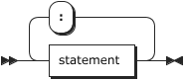

Basic compiler options

Option statement
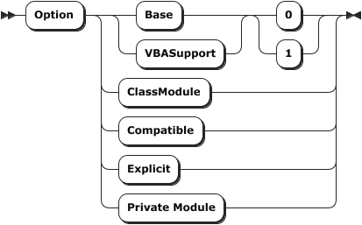

Data type conversion

Constants & variables

Scope of declarations
Type … End Type / Module
ClassModule / Library

Accessers

Constants

Variables

Dim statement
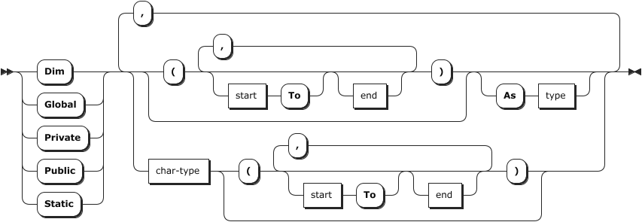
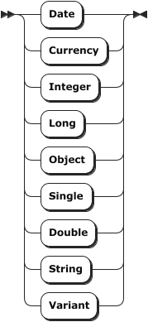
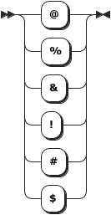char-type

Let/Set statement
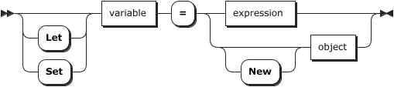

Redim statement
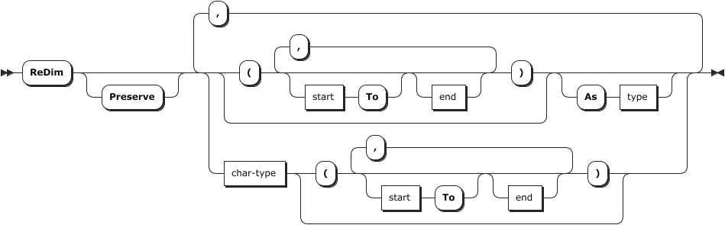

Type … End Type statement
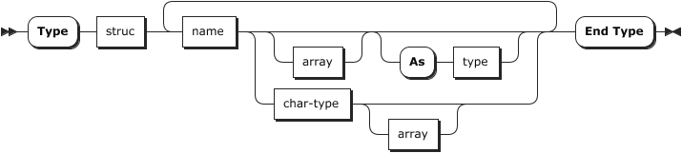

Arrays

Collections

Variants

Booleans values

Date /Time

Expressions & Operators

Procedures: Subs, Functions & Properties

Calling routines

Call statement
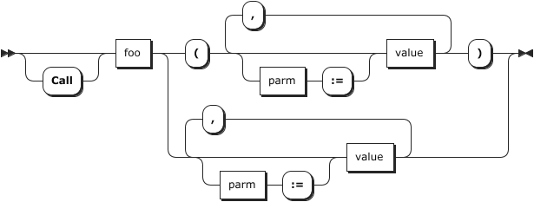

Declaring routines

Sub statement

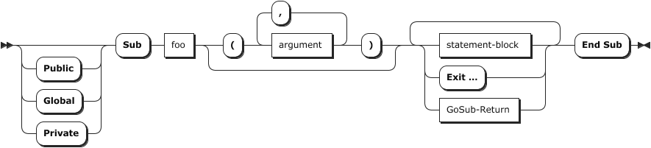
Function statement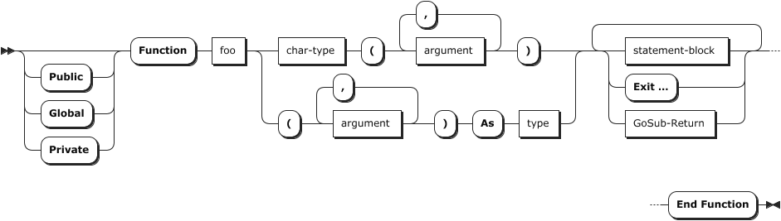

Property Get/Let statements
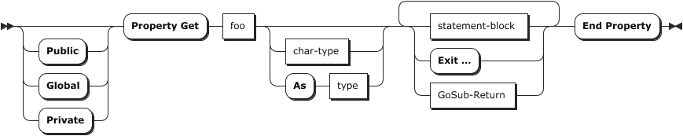
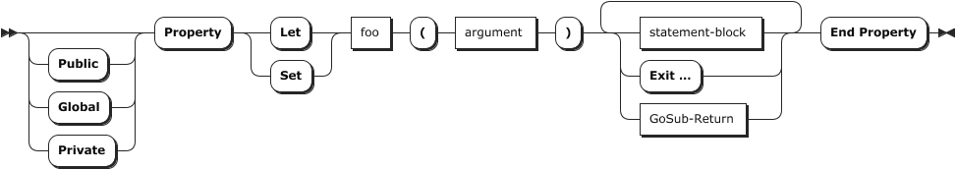

Interrupting flow: Exit …

GoSub … Return statement – Internal routines

Arguments
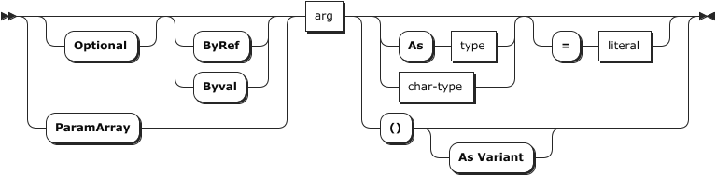

Return values
Arrays, struct, objects

File Handling

Error Processing

With LibreOffice Basic

Erl function
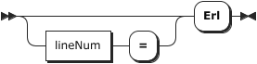

Err function
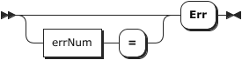

Error function
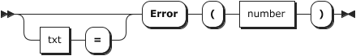

Error statement

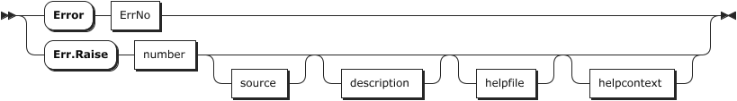
On … Error …
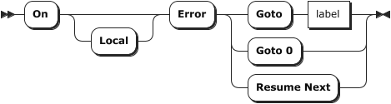

Resume statement
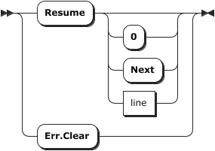

CvErr function
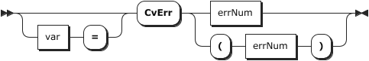

IsError function
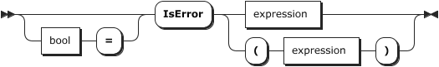

With VBA
Err.Description, Number, Source / Err.Clear, Raise

Conclusions

Exception Class - e.Number=Err, e.Description=Error$, e.Source

try: … catch: … finally: …

User-Defined Data Types & Classes

Managing Flow of Control

Testing conditions
If , Select, Iif, Choose, Switch

Iterating
For … Next …, For Each …, Do … Loop, While … Wend

Branching
Goto, On … Goto …

Internal routines

Exit … - Interrupting Flow of Control
Exit …

Events Driven programming

Beyond LibreOffice Basic

Python Scripting

JavaScript Programming
Language Reference

